Set up POP3/IMAP email - Huawei P9 Lite
1 Before you start
Make sure you have the following information: 1. Your email address 2. Password 3. Username Internet must be set up before you start this guide.

2 Swipe left
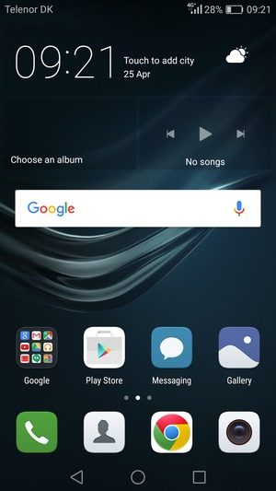

3 Select Email
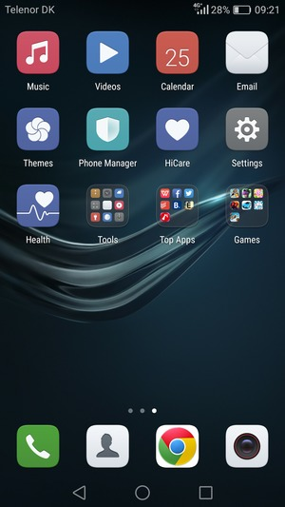
4 Select Others

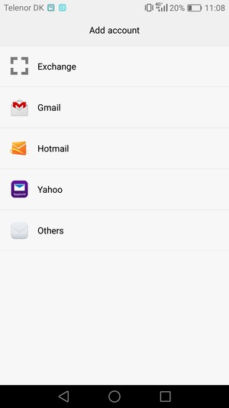
5 Enter your Email address and Password. Select Next
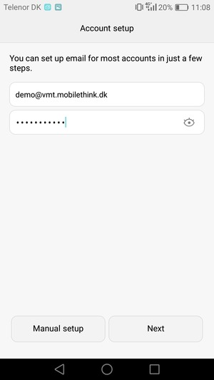
Email address
Password
6 Select POP3 or IMAP
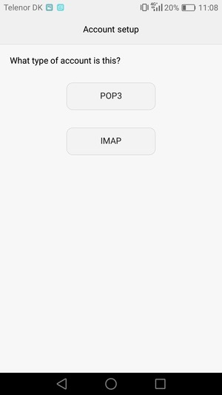
7 Enter Username and Incoming server address. Select Next
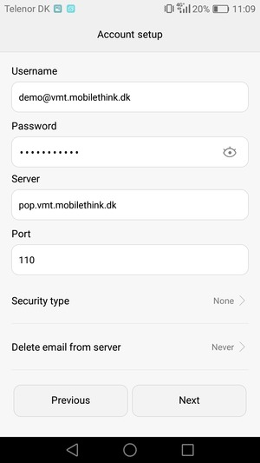
Username

8 Enter Outgoing server address
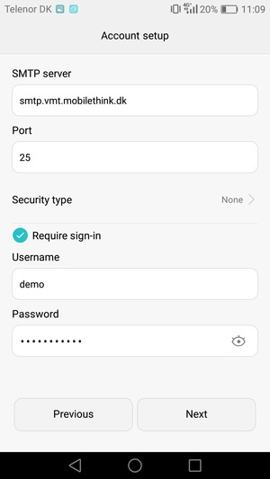
9 Uncheck the Require sign-in checkbox and select Next
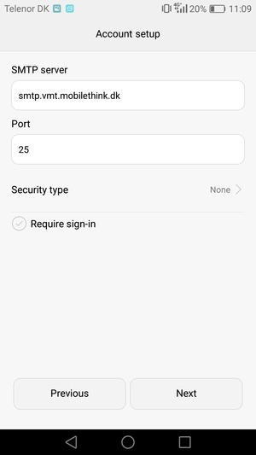
10 Select Next
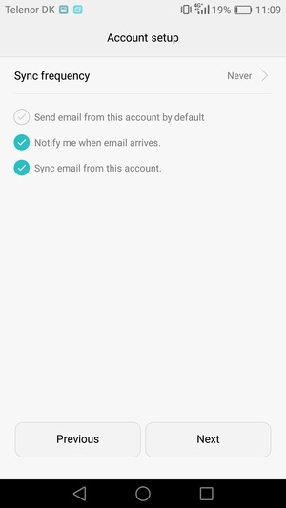
11 Your account is ready to use

